Actions in Scene2D

Actions
Actor Action Basic
- You can add an Action to all type of Scene2D Actor: Button, Image, Group...

There is two ways to add an Action:
- Shorthand: More compact but harder to read when combinign action.
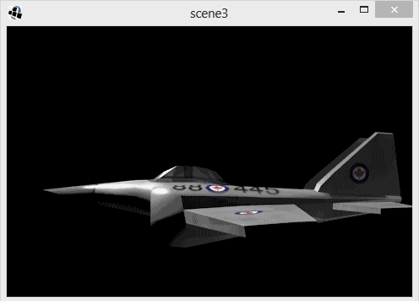
- Full declaration: Easier to read but takes los of space.

Actor action basic
Shorthand
The following shorthand Action makes an object move to a giben position
anActor.addAction(Actions.moveTo(x,y,time));

Full Declaration
Equivalent Action fully declared
MoveToAction action = new MoveToAction();
action.setDuration(duration);
action.setPosition(x,y);
actor.addAction(action);

Action pooling
To avoid allocating a new action each time it is needed, a pool can be used
Pool<MoveToAction> pool = new Pool<MoveToAction>(){
protected MoveToAction newObject() { return new MoveToAction();}};
MoveToAction action = pool.obtain();
action.setPosition(pool);
action.setPosition(x, y);
action.setDuration(duration);
actor.addAction(action);

When the action is complete it is removed from the actor and put back in the pool for reuse.
The action class provides convenience methods. It can prvide pooled actions
MoveToAction action = Actions.action(MoveToAction.class);
action.setPosition(x, y);
action.setDuration(duration);
actor.addAction(action);

The action class has methods that return a pooled and configured action
actor.addAction(Actions.moveTo(x, y, duration));

complex actions
More complex actions can be built by running actions at the same time or in sequence.
SequenceAction has a list of actions and runs them one after another.
actor.addAction(sequence(moveTo(200, 100, 2), color(Color.RED.6), delay(0.5f), rotateTO(180, 5)));

ACTION COMPLETION
To run code when an action is complete, a sequence with a RunnableAction can be used

actor.addAction(sequence(fadeIn(2), run(new Runnable() {
public void run(){
System.out.println(“Action complete!”);
}
})));

INTERPOLATION

The tweening curve can be set for actions that manipulate an actor over time.

The Interpolation class has many static fields for convenience, or you can write your own.
MoveToAction action = Actions.action(MoveToAction.class);
action.setPosition(x, y);
action.setDuration(duration);
action.setInterpolation(Interpolation.bounceOut);
actor.addAction(action);

The Actions class has methods that can take an interpolation and a static import can be used to more easily access the Interpolation static fields.
actor.addAction(parallel(moveTo(250, 250, 2, bounceOut),
color(Color.RED, 6), delay(0,5f), rotateTO(180, 5, swing)));

actor.addAction(forever(sequence(scaleTo(2, 2, 0.5f), scaleTO(1, 1, 0.5f), delay(0.5)));

